УРОК В 11 КЛАССЕ
«MY WILDEST DREAMS»
Тип урока: урок комплексного применения знаний
Учебно-методическая задача урока
Учебный аспект. Формирование и развитие навыков и умений всех видов речевой деятельности: умение работать с изученной лексикой, обсуждать проблемы по заданной теме в монологических высказываниях (до 8-10 фраз), развивать навыки письма при выполнении проекта, закрепление грамматических навыков говорения с использованием конструкций. Развитие способности к осмысленности восприятия и к распределению внимания, к слуховой дифференциации, к логическому изложению содержания высказывания, к формулированию выводов из прочитанного. Развитие способности к коммуникабельности как явному или неявному выражению своего отношения к теме
«MY WILDEST DREAMS», способности к вербализации, т.е. словесному выражению услышанного.
Формирование чувства ответственности за свое будущее. Развитие у одиннадцатиклассников познавательной активности на уроке.
Целесообразность использования презентации на уроке вызвана необходимостью показа демонстрационных фрагментов. ИКТ способствует повышению эффективности усвоения учебного материала и развивает наглядно-образное мышление учащихся.

Цели урока
Образовательные:
– систематизировать знания учащихся Модуля 7 In days to come активизировать в речи учащихся лексику по теме урока 7a «My wildest dreams»;
– учить вести беседу по теме, высказывать свое мнение;
– развивать коммуникативную компетенцию по теме урока.
Развивающие:
– развивать навыки устной речи (монологическая речь), работы с информацией, умения извлекать из различных источников необходимую информацию для последующего анализа, сравнения и обобщения.
Воспитательные:
– способствовать воспитанию активной, целеустремленной личности, стремящейся к осуществлению поставленных целей и достижению успеха;
– учить критически думать о личной мотивации, достижения личностного и профессионального становления, находить путь к самоактуализации;
– формировать социальную компетенцию;
– вырабатывать способность к рефлексии и критическому мышлению;
– формировать ценностное отношение к миру, толерантности к мнению других;
– пробудить желание быть полезным своей стране, нравственные чувства: уважение, любовь к людям.

Оборудование: компьютер, проектор, презентация

Использование форм классной работы
– фронтальная работа на этапе мотивации учебной деятельности;
– индивидуальная работа (монологические высказывания);
– групповая работа.
Образовательная технология (элементы):
технология активного и проблемного обучения, личностно-ориентированное, коммуникативное, индивидуальное, обучение в сотрудничестве, технология контекстного обучения.
ХОД УРОКА
1. Организационный этап

The teacher greets the pupils.
2. Мотивация учебной деятельности учащихся
– There are cards for you. Read and translate quotes and word combinations.
a long-life dream- мечта всей жизни
a dream come true – сбывшаяся мечта
american dream - американская мечта
a dreamer - мечтатель
Dream on! In your dreams! -Мечтать не вредно! Держи карман шире!
dream place - заповедный уголок
a pipe dream - несбыточная мечта
a lovely dream – прекрасная мечта
to be in a dream world –жить в мире грез, витать в облаках
to daydream -витать в облаках
to achieve dream - осуществлять мечту
a broken dream - несбывшаяся мечта
a lost dream - утраченная иллюзия
a cherished dream – заветная мечта
unrealized dream - неосуществлённая мечта

– What is the key-word in these cards? – DREAMS
3. Актуализация знаний
There are letters on the cards. Please, make up the topic of our lesson. Work in groups, then put the letters on the blackboard.
M | Y | W | I | L | D | E | S | T | D | R | E | A | M | S

Pronounce this topic with different intonation.
First, stress MY, then WILDEST, and at last - DREAMS

4. Создание проблемной ситуации
1. Card 1 – Dream on!
You know, the dreamers were the first who stepped into heavens and later into space.
We are going to speak about the parable (притча) of the Jonathan Seagull, who lives within us all.
Richard Bach Jonathan Livingston Seagull
(Чайка по имени Джонатан Ливингстон - 1970)
To the real Jonathan Seagull, who lives within us all
It was morning, and the new sun sparkled gold across the ripples of a gentle sea.
A mile from shore a fishing boat chummed (разбрасывать приманку) the water, and the word for Breakfast Flock flashed through the air, till a crowd of a thousand seagulls came to dodge (хитрить, ловчить) and fight for bits of food. It was another busy day beginning.
But way off alone, out by himself far from boat and shore, Jonathan [ˈʤɒnəθən] Livingston Seagull was practicing.
A hundred feet in the sky he lowered his webbed feet, lifted his beak, and strained to hold a painful hard twisting curve through his wings. He narrowed his eyes in fierce concentration, held his breath, forced one ... single ... more ... inch ... of ... curve ... Then his feathers ruffled, he stalled and fell.
Seagulls, as you know, never falter, never stall. To stall in the air is for them disgrace and it is dishonor.
But Jonathan Livingston Seagull, unashamed, stretching his wings again in that trembling hard curve — slowing, slowing, and stalling once more — was no ordinary bird.
Most gulls don't bother to learn more than the simplest facts of flight — how to get from shore to food and back again. For most gulls, it is not flying that matters, but eating. For this gull, though, it was not eating that mattered, but flight. More than anything else. Jonathan Livingston Seagull loved to fly.
This kind of thinking, he found, is not the way to make one's self popular with other birds. Even his parents were dismayed as Jonathan spent whole days alone, making hundreds of low-level glides, experimenting.
"Why, Jon, why?" his mother asked. "Why is it so hard to be like the rest of the flock, Jon? Why can't you leave low flying to the pelicans, the albatross? Why don't you eat? Son, you're bone and feathers!"
"I don't mind being bone and feathers, mom. I just want to know what I can do in the air and what I can't, that's all. I just want to know."
"See here, Jonathan," said his father, not unkindly. 'Winter isn't far away. Boats will be few, and the surface fish will be swimming deep. If you must study, then study food, and how to get it. This flying business is all very well, but you can't eat a glide, you know. Don't you forget that the reason you fly is to eat."
Jonathan nodded obediently. For the next few days he tried to behave like the other gulls; he really tried, screeching and fighting with the flock around the piers and fishing boats, diving on scraps of fish and bread. But he couldn't make it work.
It wasn't long before Jonathan Gull was off by himself again, far out at sea, hungry, happy, learning.
The subject was speed, and in a week's practice he learned more about speed than the fastest gull alive.
He couldn't be careful enough on that upstroke. Ten times he tried, and all ten times, as he passed through seventy miles per hour, he burst into a churning mass of feathers, out of control, crashing down into the water.
The key, he thought at last, dripping wet, must be to hold the wings still at high speeds — to flap up to fifty and then hold the wings still.
By sunup, Jonathan Gull was practicing again. From five thousand feet the fishing boats were specks in the flat blue water, Breakfast Flock was a faint cloud of dust motes, circling.
He was alive, trembling ever so slightly with delight, proud that his fear was under control. He was flying now straight down, at two hundred fourteen miles per hour. The speed was power, and the speed was joy, and the speed was pure beauty. We can be free! We can learn to fly! The years ahead hummed and glowed with promise.
It happened that morning, then, just after sunrise, that Jonathan Livingston Seagull fired directly through the center of Breakfast Flock, ticking off two hundred twelve miles per hour, eyes closed, in a great roaring shriek of wind and feathers. The Gull of Fortune smiled upon him this once, and no one was killed.
The gulls were flocked into the Council Gathering when he landed, and apparently had been so flocked for some time. They were waiting.
"Jonathan Livingston Seagull! Stand to Center!"
Stand to Center meant only great shame or great honor.
Stand to Center for Honor was the way the gulls' foremost leaders were marked. Of course, he thought, the Flock saw the Breakthrough! But I want no honors.
"Jonathan Livingston Seagull," said the Elder, "stand to Center for Shame in the sight of your fellow gulls!"
It felt like being hit with a board. His knees went weak, his feathers sagged, there was roaring in his ears. Centered for shame?
Impossible! The Breakthrough! They can't understand! They're wrong, they're wrong!
"...for his reckless irresponsibility," the solemn voice intoned, "violating the dignity and tradition of the Gull Family..."
To be centered for shame meant that he would be cast out of gull society, banished to a solitary life on the Far Cliffs.
The Flock might as well have been stone.
"The Brotherhood is broken," the gulls intoned together, and with one accord they solemnly closed their ears and turned their backs upon him.
Jonathan Seagull spent the rest of his days alone, but he flew way out beyond the Far Cliffs. His one sorrow was not solitude, it was that other gulls refused to believe the glory of flight that awaited them; they refused to open their eyes and see. He learned more each day.
They came in the evening, then, and found Jonathan gliding peaceful and alone through his beloved sky. The two gulls were pure as starlight, and the glow from them was gentle and friendly in the high night air. But most lovely of all was the skill with which they flew, their wingtips moving a precise and constant inch from his own.
"Who are you?"
"We've come to take you higher.
"Home I have none. Flock I have none. I am Outcast. And we fly now at the peak of the Great Mountain Wind".
"But you can, Jonathan. For you have learned.
As it had shined across him all his life, so understanding lighted that moment for Jonathan Seagull. They were right. He could fly higher and it was time to go home.
He gave one last look across the sky across that magnificent silver land where he had learned so much.
–I'm ready," he said at last.
And Jonathan Livingston Seagull rose with the two star-bright gulls to disappear into a perfect dark sky.
New sights, new thoughts, new questions. Heaven is not a place, and it is not a time. Heaven is being perfect.”
Most of us came along ever so slowly. We went from one world into another that was almost exactly like it, forgetting right away where we had come from, not caring where we were headed, living for the moment. Do you have any idea how many lives we must have gone through before we even got the first idea that there is more to life than eating, or fighting, or power in the Flock? A thousand lives, Jon, ten thousand! And then another hundred lives until we began to learn that there is such a thing as perfection, and another hundred again to get the idea that our purpose for living is to find that perfection and show it forth.
“You will begin to touch heaven, Jonathan, in the moment that you touch perfect speed. And that isn’t flying a thousand miles an hour, or a million, or flying at the speed of light. Because any number is a limit, and perfection doesn’t have limits.
The last point was the telling one.
The gull sees farthest who flies highest.
Работа с притчей:
The Flock
Jonathan Livingston Seagull
Jonathan’ dream and practice
Parents of Jonathan
An Outcast (изгнанник)
Loneliness
New sights. - Новые дали

Вывод:
Совершенство не знает предела.

2. Работа с учебником
Текст I have a dream – p. 121
Not all dreamers are winners, but all winners are dreamers. Let’s prove this saying.
Abraham Lincoln [ˈeɪbrəhæm ˈlɪŋkən]
Einstein [ˈaɪ̯nʃtaɪ̯n]
Beethoven [ˈbeɪt(h)əʊvən]
Thomas Edison [ˈtɒməs ˈedɪsən]
What word- combinations are fitted here?
a dream come true – сбывшаяся мечта
american dream - американская мечта
to achieve dream - осуществлять мечту
5. Speaking
Dream is the key to your future… you need a dream if you are going to succeed in anything you do.
1. Ex. 6 p. 121 – What do you think your future will be like?
I see myself in …
I’m thinking about a career in …
I’ve always dreamed of being …
I long to become a …
My goal is to … / Ving
My highest ambition is to become a …
Ving is my number one priority.

What word- combinations are fitted here?

You must realize you’d got too kiss some frogs before you find your prince of a job.
2. My wildest dream is …
Мини-проекты учащихся (выборочно)
1). Write down your wildest dream.
2). Make a plan for turning them into reality.
Начинайте с глагола. Придерживайтесь порядка слов в предложении:
Do what / with what / whom
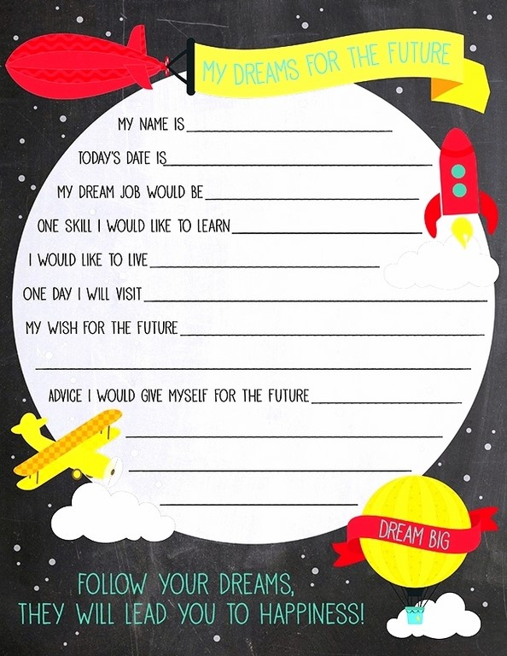
6. Hometask

Question naire “My dreams for the future” (Заполнить анкету)
7. Рефлексия (подведение итогов занятия)
(проводится в конце урока в письменной форме. Учащиеся должны ответить на вопросы.)
So, let’s sum up. Today our lesson was dedicated to dreamers of all times.
Please, answer 4 questions. Write down your answers into the worksheets.
8. Учитель называет фамилии детей и выставляет им оценки.
Thank you for your hard work, our lesson is over, good bye!

